**Advanced Networking Research Assignment  
Submission Date: 03-04-2022**

Student: Anthony Legg

ID#: 03007276

**Table of Contents**

Introduction 3

Automated Network Management 3

Advantages of Automated Network Configuration Software 4

Automated Network Configuration Software Concepts 5

Automated Network Configuration Software Options 5

Ansible 5

Chef 6

References 7

“*The first rule of any technology used in a business is that automation applied to an efficient operation will magnify the efficiency. The second is that automation applied to an inefficient operation will magnify the inefficiency.*” *-* **Bill Gates**   
(Stancombe, 2015)

Introduction  
This report will introduce automated network concepts and considerations in relation to the current network infrastructure at ACME.com. Currently, ACME.com has four locations in New Zealand including the head office, and twelve in Australia. Each location relies heavily on the network infrastructure, which comprises of ten servers, fifty-one routers, and ninety switches. This hardware is currently managed manually from ticket tracking, documentation through to performing configuration changes on a per site, device, or user basis, through the command line. This approach makes it difficult to gain an accurate overview of the current network state, performance, and security. Automated network configuration tools enable efficient management of the network infrastructure, maximising its uptime, while ensuring it is resilient and secure.

# Automated Network Management

Automation is intended to enable people to focus on higher level, complex tasks by autonomously completing frequently performed, time-consuming tasks. Automation helps you standardize network management processes to enforce best practices. (RedHat Inc, 2020). Automated network configuration software enables network administrators to describe the desired state of target devices as version-controlled code (Visualpath IT, 2020).

# Advantages of Automated Network Configuration Software

1. **Simplification**: perform day to day network management tasks
2. **Enforcement and fast failure recovery**: round the clock monitoring of network devices; code can be redeployed to return devices back to a predefined configuration/state; quick restoration of the network with minimal disruption (Visualpath IT, 2020).
3. **Maintenance and scalability**: Scheduled deployment of configuration changes during low peak traffic; per time zone, network, specific subnets or VLANs.
4. **Patch management**: deployment and management of software patches; incremental deployment to minimise disruption to network services.
5. **Access and security management**: firewalls, access-lists, IP addressing is managed centrally, and is distributed where needed.
6. **Agile network management and collaboration:** network administrators are able respond to develop, review, test and monitor network configuration changes.
7. **Monitoring and reporting**: Alert administrators of hardware issues, monitor configuration changes, report failures, unsecure or devices that are not in compliance with the standards.
8. **Version control and backup**: infrastructure code is version controlled and backed up, allowing quicker restoration of the network in the event of a natural disaster, outage, or total loss of network.
9. **Reduced network management costs**: reduction of overtime hours and time troubleshooting manual configuration issues.
10. **Performance oversight and capacity planning**: performance reporting capabilities ensure resources are utilised more efficiently, targeting areas of the network which require investment.

# Automated Network Configuration Software Concepts

System automation tools typically requires an agent to be installed on each target system to be managed. Network devices operate with firmware provided by the manufacturer and are not able to have third party applications or agent software installed (Gargano, 2020). This feature ensures network hardware performs consistently and securely.

* **Agent-based configuration**: agent-based tools require agent software to be installed on each target device to be managed (Gargano, 2020).
* **Agentless configuration**: Agentless tools do not require agent software to be installed on the target device; agentless software communicate with devices via SSH or an API (Gargano, 2020).
* **Proxy-agent configuration**: Like agentless, does not require agent software to be installed on the target, but will require a system to process communications between the master service and the target device (Gargano, 2020).

These technologies typically use one of two forms of language to structure the infrastructure in code.

* **(DSL) Domain-Specific Language**: is specific to the platform used to configure the network. This has a steep learning curve for the network administrator to adopt the technology.
* **(SML) Structure Mark-up Language**: utilises easily understood languages and mark-up, such as YAML. This enables network administrators and non-programmers to adopt the technology much faster, and with less errors.

# Automated Network Configuration Software Options

## Ansible

1. Based on python programming language and YAML data format.
2. Agentless, no agent software required on target devices
3. push model used to get configurations from target devices
4. uses SSH communication protocol to communicate with target nodes
5. Controller node can be deployed on any system within the network.

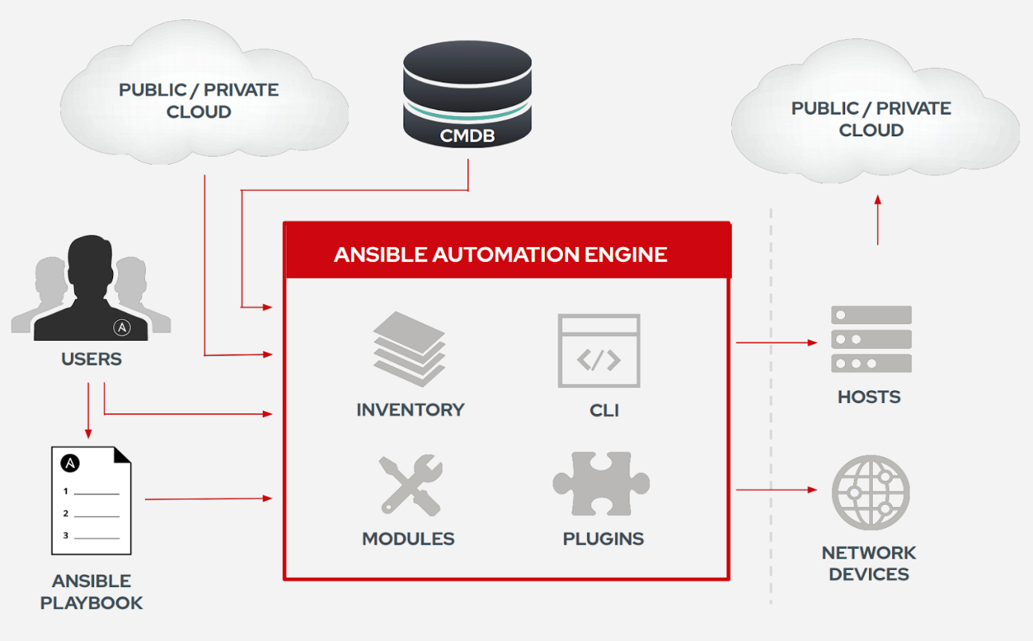

(Estevão & Miranda, 2020)

## Chef

1. Chef server node manages all devices; stores, manages, and provides all the required configurations to the agent devices.
2. Chef client node, managed device
3. It is written by Ruby DSL (Domain Specific Language).
4. Nodes use API to communicate
5. Agents pull configuration changes from the chef server node

Code files in Chef is referred to as Cookbooks. Recipe is the code being deployed. Chef Workstation is the system administrator use to interact with Chef management tools, create and deploy recipes (Study CCNA, 2021).

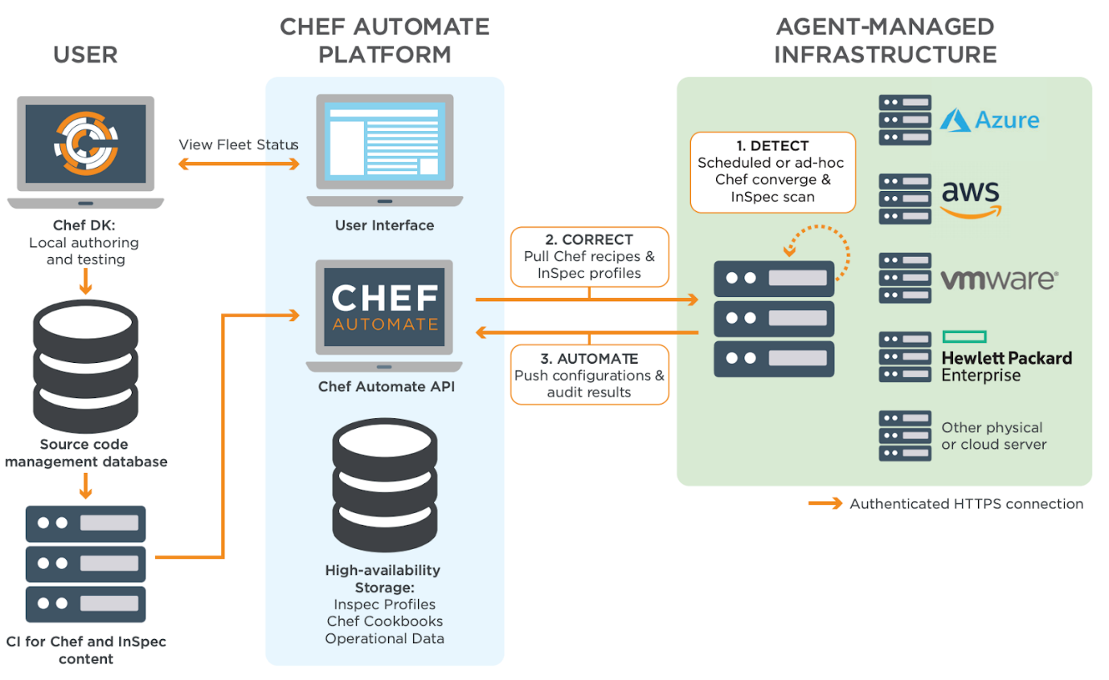 (IPCisco, 2020b)

# References

Cooper, S. (2021, December 2). *6 best network automation tools for 2022*. Comparitech.com; Comparitech Limited. https://www.comparitech.com/net-admin/network-automation-tools/

Estevão, D., & Miranda, R. (2020, April 27). *The definitive guide to configuration management tools*. Coralogix; Coralogix LTD. https://coralogix.com/blog/the-definitive-guide-to-configuration-management-tools/

Frederick, N. (2022, February 8). *Network automation tools*. ManageEngine Blog; Zoho Corporation Pvt. Ltd. https://blogs.manageengine.com/network/network-configuration-manager/2022/02/08/network-automation-tools.html

Gargano, P. (2020). *Configuration management tools network automation*. Ciscopress.com. https://www.ciscopress.com/articles/article.asp?p=3100057&seqNum=3

IPCisco. (2020a, May 24). *Ansible tutorial network automation tool playbook*. IPCisco; IPCisco. https://ipcisco.com/lesson/ansible-overview/

IPCisco. (2020b, May 24). *Chef software chef server workstations*. IPCisco; IPCisco. https://ipcisco.com/lesson/chef-overview/

RedHat Inc. (2020, July 8). *What is network automation?* Understanding Automation; RedHat Inc. https://www.redhat.com/en/topics/automation/what-is-network-automation

RedHat Inc. (2021). Network automation for everyone modernize your network with red hat ansible automation platform. In *redhat.com*. Red Hat Inc. https://www.redhat.com/rhdc/managed-files/rh-network-automation-for-everyone-ebook-f26682-202101-en_0.pdf

SolarWinds. (2016). *What is network automation?* Solarwinds.com; SolarWinds. https://www.solarwinds.com/resources/it-glossary/network-automation

Stancombe, C. (2015, January 2). *Tempted to rewrite bill gates’ rules on automation?* Capgemini Worldwide; Capgemini Worldwide. https://www.capgemini.com/2015/01/tempted-to-rewrite-bill-gates-rules-on-automation/

Study CCNA. (2021, September 17). *Configuration management tools - ansible, chef, puppet*. Study CCNA; study-ccna.com. https://study-ccna.com/configuration-management-tools-ansible-chef-puppet/

Visualpath IT. (2020, May 22). *Chef is a popular tool for configuration management of it. infrastructure. its flagship enterprise solution,...* Linkedin.com; LinkedIn. https://www.linkedin.com/pulse/6-benefits-chefs-infrastructure-automation-tools-visualpath-training

‌